

SD Request Form

USER GUIDE

Version 1.1  
February 24, 2021

|  |  |  |  |
| --- | --- | --- | --- |
| Date | Version | Changed By | Changes |
| 02/17/2021 | No Versioning | Maryna Nikolaienko | Original Version |
| 02/23/2021 | Version 1.0 | Keith Brickey | Edited for grammar |
| 02/24/2021 | Version 1.1 | Maryna Nikolaienko | * the document is divided into sections; * added heading to each section; * added table of contents; * added information on SD Form statuses for each Scope. |

Table of Contents

Main areas of SD Request form 4

Project Information 6

Document Needed 6

Shop Drawing Form 7

List of schemes 7

Cabinets and Countertops Shop Drawing Schemes for Scope 9

Flooring SD Scheme for Scope 10

Configuration menu for filling SD form template 12

# Main areas of SD Request form

For each Scope in the Project for which the SD is required, a Shop Drawing Form is displayed in a separate area. There are three scheme types for the SD Form, depending on Scope: 3D Cabinets, 2D Flooring, 2D Countertops. The configuration of the binding of Scope to a specific scheme of the SD Request is configured in the Scopes Template menu.

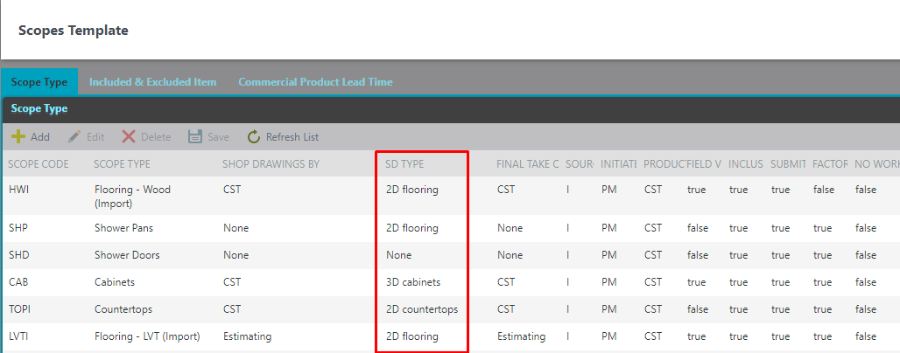

The SD Request form consists of three separate areas: Project Information, Document Needed and Shop drawing form for each Scope. There are two role users who will work with the SD Request Form: Estimator and Sales, which are assigned to the current project. The estimator is the first to fill out the form and is able to start the SD Request process using the "SD Request" button on the MyProject menu.

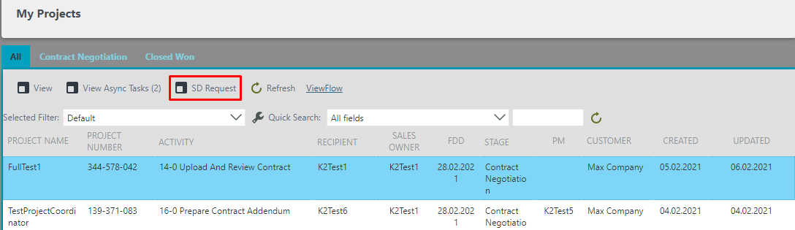

After filling in all the fields to start the process, use the Start SD Request Process button.

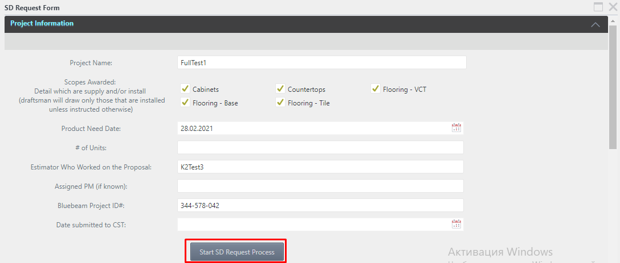

At the same time, the estimator has an unlimited opportunity to edit and save the form before starting the process. After starting the process, the form moves through the workflows and gets into the work of the Sales. Other users can see the form only after the start of the SD Request process in read mode using the same "SD Request" button on the MyProject menu. The SD Request form is also available in the separate steps of the ProjectScope Process in the tab «SDRequest». If the SD Request process has not been previously started by Estimator and filling out the SD form for a specific Scope is necessary, ProjectScopeProcess proceeds to steps 5-0, 5-1 and 5-2, where the work with the SD Request form takes place. The only difference is that the Shop Drawing area is only displayed for a specific Scope of the current ProjectScopeProcess. After passing the specified steps and confirming the SD form, the SD Request tab is displayed for all users in read mode at individual steps of the ProjectScopeProcess.

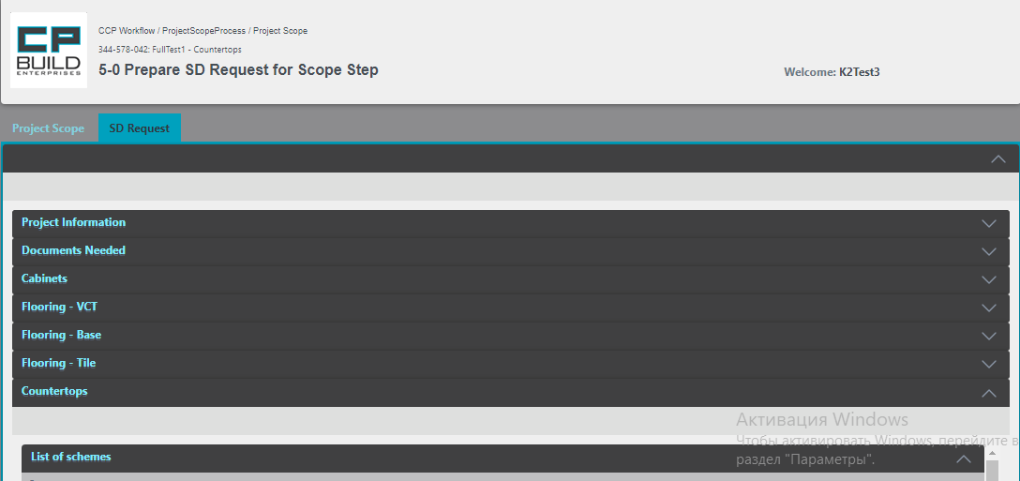

The Shop Drawing area of specific Scope has several statuses. Depending on the process, there are 3 options for status: Initiated, Started, Approved.

|  |  |  |
| --- | --- | --- |
|  | SD Request process | Project Scope process |
| Initiated | after saving the first Version in My Project Menu | after saving the first Version in step 5-0 |
| Started | after the Start of the process | after Submit in step 5-0 |
| Approved | after the Finish of the process | after Submit in step 5-2 |

## **Project Information**

In the Project Information area, you can see general information on this project, including Project Name, Product Need Date etc. You will also see all scopes for which SD Request schemes have been created in the project. This area is not editable.

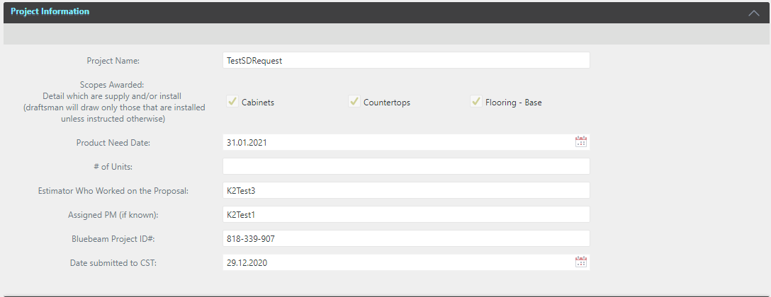

## **Document Needed**

The Documents Needed area offers the ability to link files to a specific document type. Type of document contains a complete list of all possible document types for use in an SD Request.

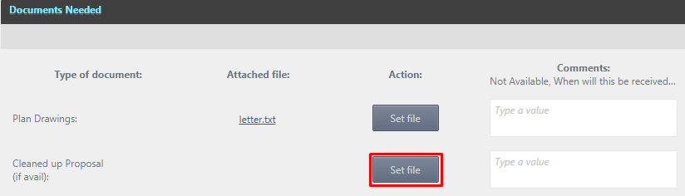

When you click the Set File button, the Mapped Attachment sub form opens with a complete list of attachments that were previously added to the project displayed. To map an attachment, select it with one click of the left mouse button and press Select.

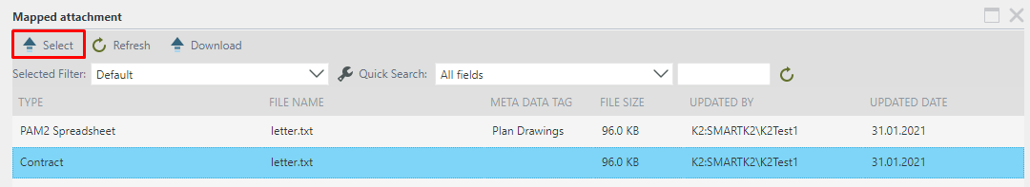

The "Attached file" field for a certain type of document will display the file that was mapped with the ability to download it, if necessary (the file download link is highlighted in the file name)

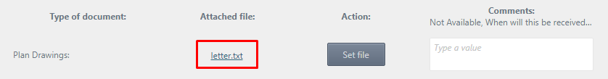

After this action, all Attachment Lists Project will display information about the mapped file to SD Request, indicating the document type in the Meta Data Tag field

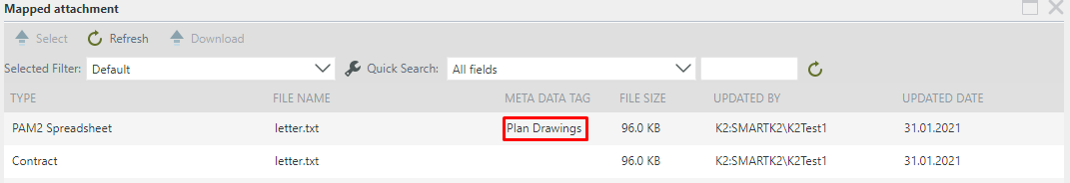

By clicking the Set File button again, you can re-map another document in the selected file type. In the Comments field, you can add a comment for each file type

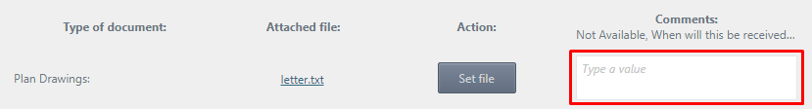

## **Shop Drawing Form**

The Shop Drawing form for scopes consists of two areas: List of Schemes and a direct Shop Drawing form with a list of items

### ***List of schemes***

The part shows general Comments on SD Form for Scope

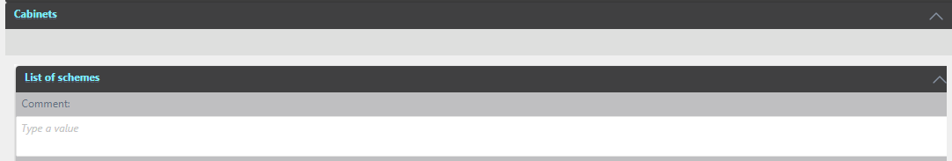

This part displays schemes related to the SD Form for Scope.

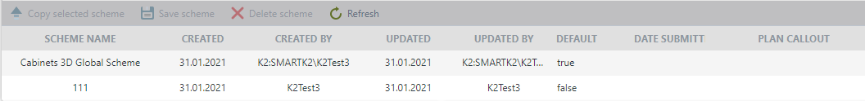

The toolbar menu shows buttons responsible for managing schemes. To do this, it is necessary to select the necessary scheme with which we will carry out manipulations



Copy selected scheme – this button will copy the selected scheme. To do this, select a scheme to copy and click Copy Selected Scheme.

 A new line will then appear where you will need to enter the desired Scheme Name. Submission Date Submit, Plan Callout - optional.

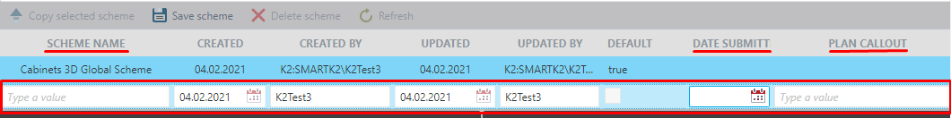

Save scheme – After filling in these fields, click the Save Scheme button.

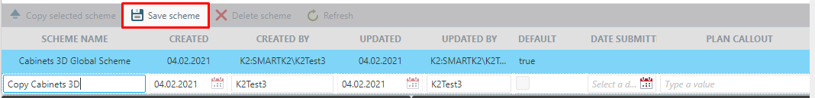

Note that there are two statuses in Default: true - which indicates that this is a global scheme; false - shows that this is one of the copies of the global scheme.

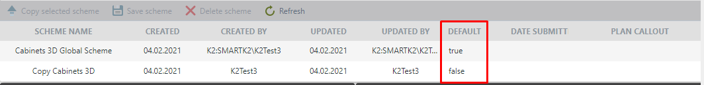

Delete scheme – To delete any of the schemes, select the scheme and click the Delete Scheme button. Please note that only copies of schemes can be deleted.

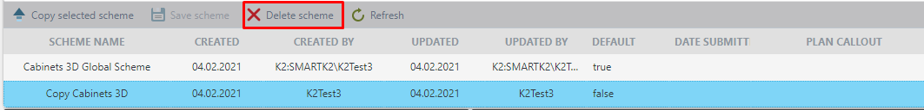

Refresh – this button is responsible for updating the List of schemes.

**Cabinets and Countertops Shop Drawing Schemes for Scope**

The next block is divided into two panels, right and left. The left one is the workspace of the current user with a choice of scheme versions and the presence of form editing fields. The right panel is used to compare changes made by another user. The first time filling out the form, the right side will be blank.

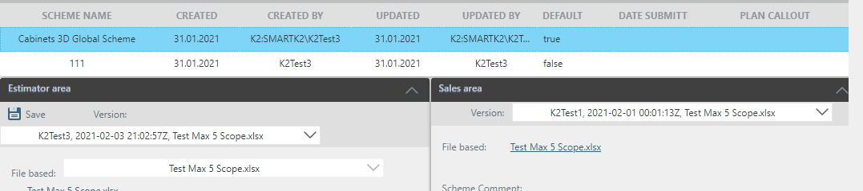

To work with the Scheme - you need to select the scheme with which the work will be performed, and go to the next block, in which on the left it is necessary to enter values for all the required items of the form. If some value in the form is selected and Lock a Field is set, then the following users will not be able to change this record.

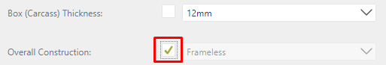

After weighing all the changes in the form, you save it. In this case, press the Save button.

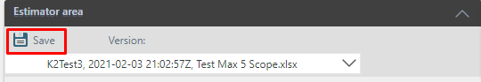

A message will be displayed to confirm that the form has been saved.

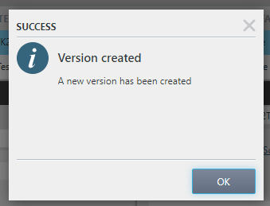

Every time the form is saved, a new version is created. This can be found in the Version list. When loading a global scheme, the last saved version is always displayed first in the Version list.

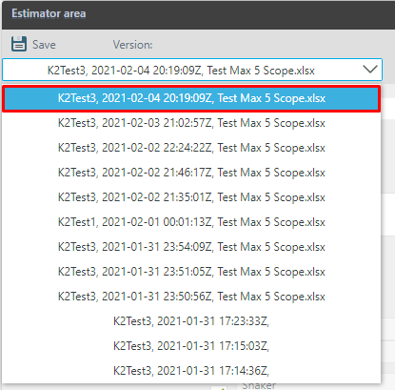

At the top of this area, File Based also shows the name of the last file displayed in the "Quotation File" field. The link to download this file is below.

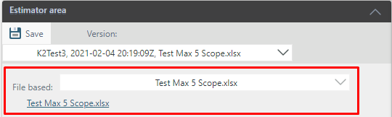

The next part shows the general comments on the SD form for Scope. In Scheme Comments, a comment is added for each scheme. If we change the version, the comment does not change.

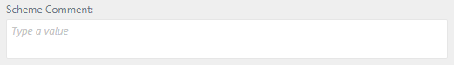

When there is a discrepancy between data records, a "Function arrow" appears on the right and left panels. This is necessary for convenient fast data transfer. When you click on it, the data on the right side of the work area is filled in the corresponding fields on the left side of the work area.

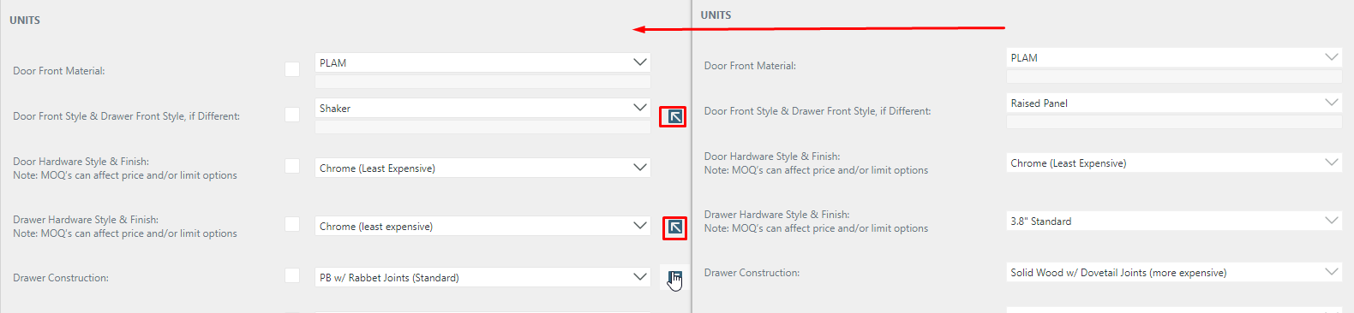

## **Flooring SD** **Scheme for Scope**

Controls for Version, File Based, Scheme Comment fields are identical to those in Cabinets and Countertops.

The data in the Flooring Shop Drawing form is imported from the last Quotation file and formed into a list view. In the rework process, the user can edit, add or delete existing lines, after importing data. After making changes to the list and clicking the refresh button, the changes will be canceled. Click the Save button to save your changes. A new version will be created every time the data is saved.

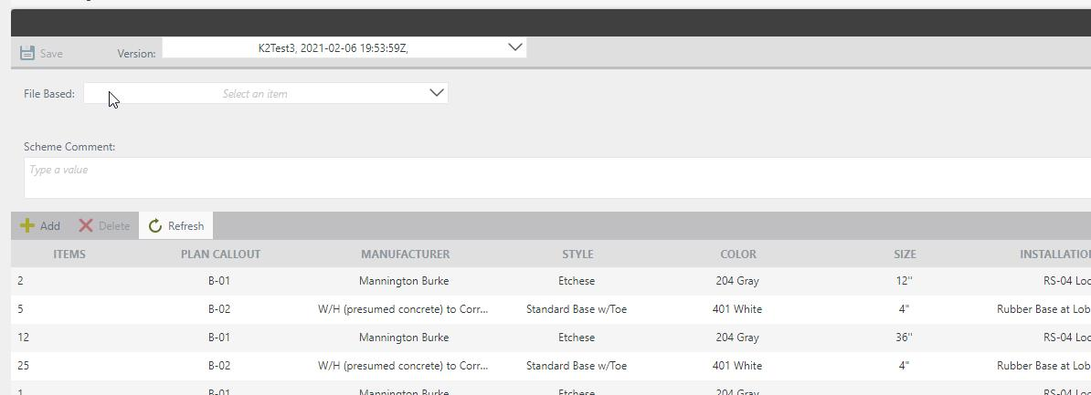

The editing panel contains tools for adding a record. Editing is done by double-clicking the left mouse button on the required entry and deleting an existing record with preliminary highlighting of the required record. Refreshing the workspace without first saving, will reset all records to the original and ported version. To work with a record (add new row in list), the required fields are: Items, Plan Callout and Manufacturer.

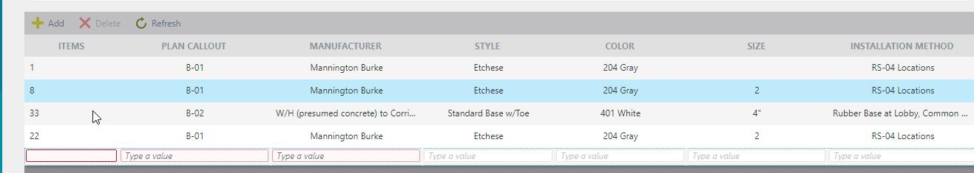

To save all the changes made, click on the Save button. Each time you save, a new version is created.

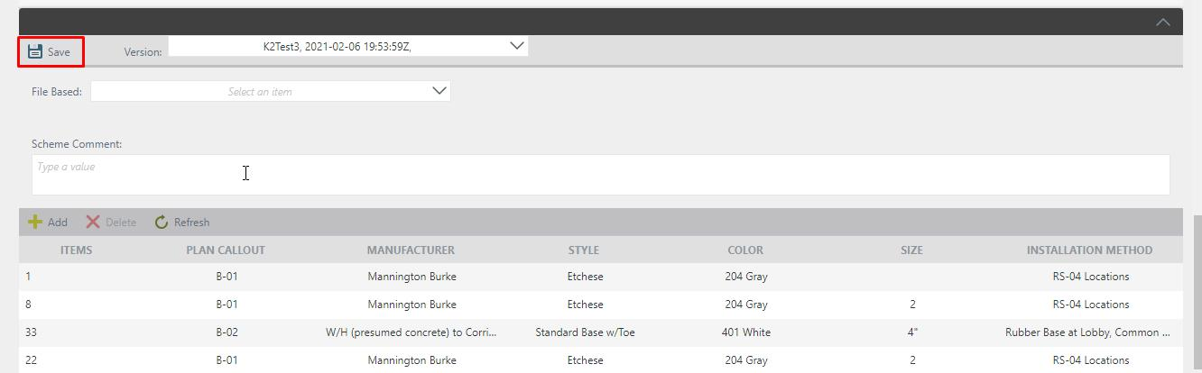

To configure the list of values ​​in the SD form, there is a separate menu in the Configure panel called SD Options. This makes it possible to edit, add or remove options for selecting values ​​for data entry. This configuration menu is available exclusively for the CCP administrators.

# Configuration menu for filling SD form template

In Configuration Management, select Application Configuration. In the list that opens, select SD Options.

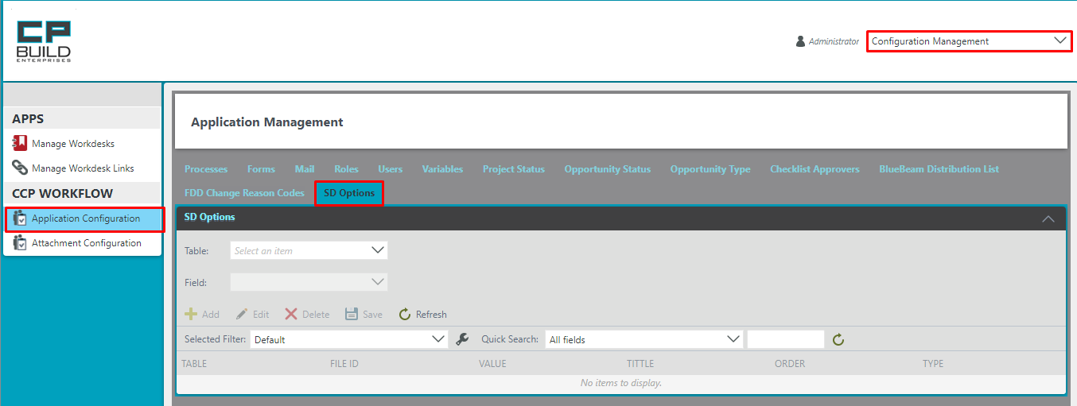

To make the work more convenient, the configuration menu contains filters: selection of the Scheme for editing and also selection of the table, the data values ​​for which should be changed.

The meaning of the fields is as follows:

* table: an area on the diagram of the SD form that contains data with a common parameter
* value: the value that will be transmitted and written as a system value to the database
* title: the name of the value that is displayed on the form
* order: a numeric value which is responsible for the order of placing items. Items with the

lowest order value are displayed first.

* type: informative field for displaying the type of field for data entry (checkbox, radio button,

text field, etc.)

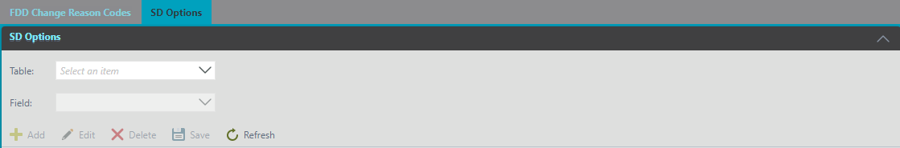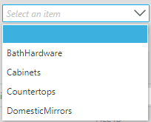

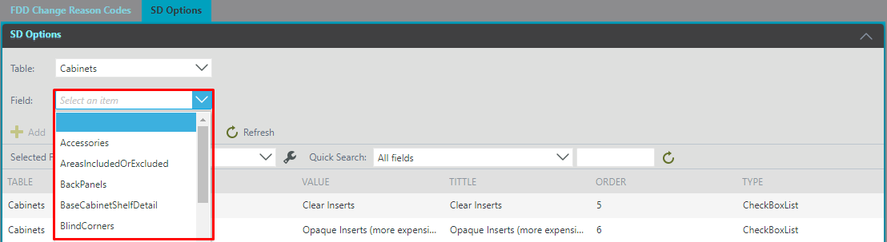

The toolbar panel contains tools for adding a record; editing or deleting an already existing entry, while pre-highlighting the desired entry; saving editing and workspace update.

